1. Java Sort:
#code:
import java.util.*;

class Student {
private int id;
private String fname;
private double cgpa;

public Student(int id, String fname, double cgpa) {
super();
this.id = id;
this.fname = fname;
this.cgpa = cgpa;
}

public int getId() {
return id;
}

public String getFname() {
return fname;
}

public double getCgpa() {
return cgpa;
}
}

public class Solution {
public static void main(String[] args) {
Scanner in = new Scanner(System.in);
int testCases = Integer.parseInt(in.nextLine());

List<Student> studentList = new ArrayList<Student>();
while (testCases > 0) {
int id = in.nextInt();
String fname = in.next();
double cgpa = in.nextDouble();

Student st = new Student(id, fname, cgpa);
studentList.add(st);

testCases--;
}

Collections.sort(studentList, new Comparator<Student>() {
@Override
public int compare(Student s1, Student s2) {
if (Double.compare(s2.getCgpa(), s1.getCgpa()) != 0) {
return Double.compare(s2.getCgpa(), s1.getCgpa());
}
if (!s1.getFname().equals(s2.getFname())) {
return s1.getFname().compareTo(s2.getFname());
}
return Integer.compare(s1.getId(), s2.getId());
}
});

for (Student st: studentList) {
System.out.println(st.getFname());
}
in.close();
}
}

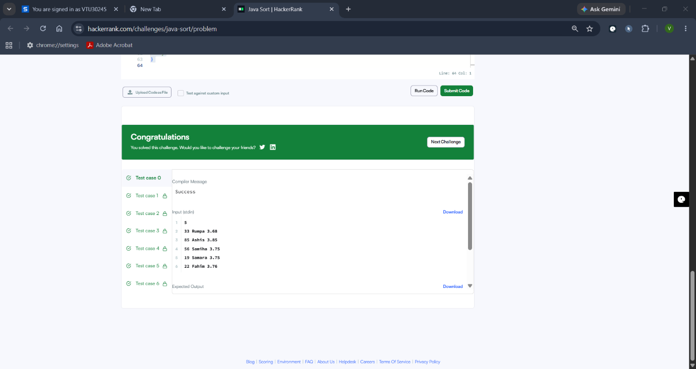

2. Sort Array By Parity:
#code:
class Solution {
public int[] sortArrayByParity(int[] nums) {
int left = 0;
int right = nums.length - 1
while (left < right) {
if (nums[left] % 2 > nums[right] % 2) {
int temp = nums[left];
nums[left] = nums[right];
nums[right] = temp;
}
if (nums[left] % 2 == 0) left++;
if (nums[right] % 2 != 0) right--;
}
return nums;
}
}